Links to Resources for Chapter 3:

1. Saunders books: https://primo.anglia.ac.uk/primo-explore/fulldisplay?docid=44APU_ALMA2138938310002051&context=L&vid=ANG_VU1&search_scope=CSCOP_APU_DEEP&isFrbr=true&tab=default_tab&lang=en_US

2. Collis and Hussey Book: https://primo.anglia.ac.uk/primo-explore/fulldisplay?docid=TN_dawson9781137037480&context=PC&vid=ANG_VU1&search_scope=CSCOP_APU_DEEP&tab=default_tab&lang=en_US

3. Research Methods Handout- http://samuellearning.org/Research_Methods/RM%20handout_2%20_Jan2016.pdf

4. Buchanan, D. A., & Bryman, A. (2007). Contextualizing Methods Choice in Organizational Research. Organizational Research Methods, 10 (3), 483–501. (Links to an external site.)
5. Guba, E.G. and Lincoln, Y.S. (1994). Competing Paradigms in Qualitative Research. In: N.K. Denzin and Y.S. Lincoln, ed. 1994. Handbook of Qualitative Research. 3rd Edition ed. Thousand Oaks, CA: Sage, pp.105-17. https://eclass.uoa.gr/modules/document/file.php/PPP356/Guba%20%26%20Lincoln%201994.pdf (Links to an external site.)
6. Denzin, N. K., & Lincoln, Y. S. (Eds.). (2004). The Discipline and Practice of Qualitative Research: In the handbook of qualitative research. Thousand Oaks, CA: Sage https://www.sagepub.com/sites/default/files/upm-binaries/40425_Chapter1.pdf (Links to an external site.)
7. Creswell (2006). Five Qualitative Approaches to Design: In Qualitative Inquiry and Research Design: Choosing among Five Approaches. Thousand Oaks: Sage https://www.sagepub.com/sites/default/files/upm-binaries/13421_Chapter4.pdf
8. Sue, V.M. & Ritter, Lois A., 2016. Conducting online surveys, 2nd Edition. Los Angeles : SAGE https://primo.anglia.ac.uk/permalink/f/2d52r0/44APU_ALMA5177804250002051

Chapter 3 Research Design and Methodology

3.0 Introduction
Define Research Design. Use the Honeycomb Model (Wilson 2013) to outline the typical contents of the chapter.
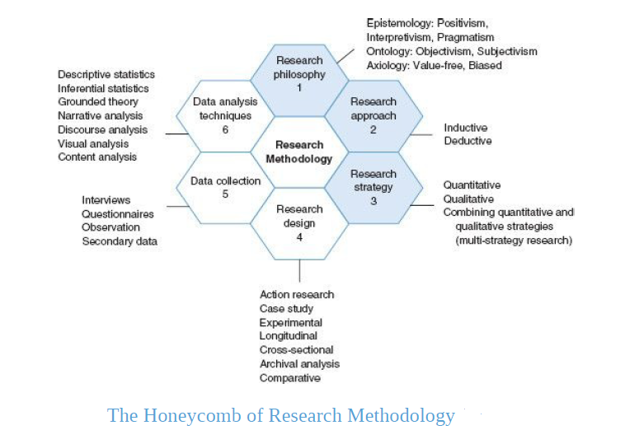

3.1 Research Paradigm (see pg. 36-50 Wilson text)
Define Research Paradigm- make sure to say that it is influenced by key philosophical assumptions.

3.1.1 Research Philosophy
Start with a discussion of Epistemology- Knowledge and Knowing
Decide on whether you are using a Interpretivism OR Positivistic paradigm OR Pragmatism
Discuss Ontology- Reality
Decide whether your research will be based on an Objective or Subjective stance.
Justify your choices by using literature and apply to your research context.
It might be useful to say why the other cannot work or why it might not be applicable

3.1.2 Research Approach
Define both Inductive and Deductive Approaches
Must discuss whether you are using Inductive or Deductive role of theory
It is important that you justify your choice given the context of your research
It might be useful to say why the other cannot work or why it might not be applicable

3.1.3 Research Strategy
Define Quantitative, Qualitative and Mixed Methods
You must then relate that to whether you are following a Quantitative or Qualitative approach or Mixed Methods
Justify your choices by using literature and apply to your research context.
It might be useful to say why the other cannot work or why it might not be applicable

3.2 Research Design (see pg. 172 Wilson Text)
Give an overview of action research, survey, case study and Archival Research.
Then say for this this research X design would be used.
Should justify your choice, again use literature and apply to your research context.
Must give the time horizon of your research, either Longitudinal or Cross Sectional

3.3 Data Collection (see pg. 219 Wilson text)
Give a brief introduction into your data collection; both primary and secondary data will be collected in order to achieve the research objectives.

3.3.1 Questionnaire
Discuss clearly and in detail:
Purpose of questionnaire- Which objective will be achieved through the questionnaire?
Participants- Specify Who,
Sampling- Sampling Method used, calculated sample size and response rate,
Distribution and collection method- how did you disseminate the questionnaire, use of PIS
Data collected- Include your Factors Table here- table showing the themes you used to ask questions and the authors

Factors/Theme | Questions | Authors
-
-
-

Type of questions used e.g. 5 point Likert Scale or category questions

3.3.2 Interviews
Discuss clearly and in detail:
Purpose of interview- Which objective will be achieved through the interview?
Participants- Specify Who,
Sampling- Sampling Method used, how many persons,
Type of Interview- unstructured or semi-structured
Mode of Interview- face to face or video conference
Data collected- what themes were used to ask questions. Include your Factors Table here
Factors/Theme | Authors

Interview preparation- use of PIS, choice of location, recording the interview

3.3.3 Secondary Data (see pg. 264 Wilson text)
Define secondary data, outline sources of secondary data.
Discuss the specific documents that you are using to compile your research findings. E.g Industry reports, Best practice reports etc.

3.3.4 Summary of Data Collection
Use the table below to summarize your data collection methods usage
Objective | Who/Where?  Source | Data Needed Factors/Themes | How will the Data be collected?  Method

3.4 Data Analysis Plan
Introduction to the types of data that will be collected. So questionnaires will give Quantitative data, Interviews will give Qualitative Data. Therefore, the research will require both types data analysis.

3.4.1 Quantitative Analysis (see pg. 318 Wilson text)
Outline process of transforming the raw data i.e. sorting, coding, data entry
Discuss the use of:
- Descriptive Statistics- Tables, Distribution Frequencies, Cross Tabulation, Central Tendency (Mean, Median, Mode), Scatter Diagrams, Graphical Forms (Pie, Bar etc)
2. Inferential Statistics- Forecasting, Time Series, Pearson’s Coefficient, Spearman’s Rank Coefficient, Chi Squared and Student t-test

3.4.2 Qualitative Analysis (see pg. 378 Wilson text)
Discuss the use of Thematic Analysis which is rooted in Narrative Analysis.
Use Creswell (2009) model:
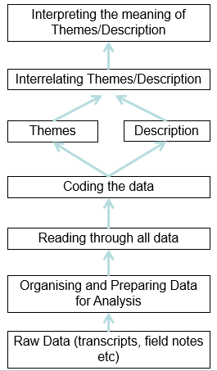
Discuss process of transforming the raw data i.e. transcription, reading, making notes, categorizing into themes, describing the themes, interrelating the themes.

3.5 Ethics (see pg. 139 Wilson text)
Define Ethics in Research
Outline the likely ethical issues you will encounter (Use Ethics App Form Section 2, Questions as a guide)
You must then outline your tactics to mitigate the ethical risks (Use Ethics App Form Section 4)
If applicable, refer to the PIS and PCF in appendix

3.6 Limitations to Research Methodology
Every methodology would have some limitations
Discuss the Issues that might affect the quality of the research i.e. Reliability and Validity
Discuss the obstacles you may have encountered e.g. response rates, access to interviewees

